**DIGIMART APP DESIGN USING IONIC FRAMEWORK**

A Term Paper Report

Submitted in partial fulfillment of the requirements for

the award of the degree of

Bachelor of Technology

in

ELECTRONICS AND COMMUNICATION ENGINEERING

by

**D. MOHAN VAMSI-(150040191)**

**H. UDAY BHASKAR-(150040295)**

**K. DEEPAK-(150040403)**

**N. JAYA SIMHA REDDY-(150040588)**

under the supervision of

**MR.SRIPATH ROY KOGANTI**

**Asst.Prof/ECE**

**KLGLUG**



**KONERU LAKSHMAIAH EDUCATIONAL FOUNDATION**

**Green Fields, Vaddeswaram, Guntur(Dist.)- 522502**

**Andhra Pradesh, India.**

**April, 2018**

**KONERU LAKSHMAIAH EDUCATIONAL FOUNDATION**



**Green Fields, Vaddeswaram**

**DEPARTMENT OF ELECTRONICS AND COMMUNICATION ENGINEERING**

**Declaration**

The Term Paper Report entitled “ Digimart App Design using Ionic Frame Work“ is a record of bonafide work by **D. MOHAN VAMSI-(150040191), H. UDAY BHASKAR-(150040295) , K. DEEPAK-(150040403), N. JAYA SIMHA REDDY-(150040588)** submitted in partial fulfillment for the award of B. Tech in **OPEN SOURCE** to K L Deemed to be a University. The results embodied in this report have not been copied from any other department/University.

|  |  |  |  |
| --- | --- | --- | --- |
| S.NO | NAME | ID – NO | SIGNATURE |
| 1 | D.MOHAN VAMSI | 150040191 |  |
| 2 | H.UDAY BHASKAR | 150040295 |  |
| 3 | K.DEEPAK | 150040403 |  |
| 4 | N.JAYA SIMHA REDDY | 150040588 |  |

**KONERU LAKSHMAIAH EDUCATIONAL FOUNDATION**

**Green Fields,**

**Vaddeswaram**

**DEPARTMENT OF ELECTRONICS AND COMMUNICATION ENGINEERING**



**Certificate**

This is to certify that the Term Paper Report entitled “Digimart App Design using Ionic Frame Work” is being submitted by **D.MOHAN VAMSI-(150040191), H. UDAY BHASKAR-(150040295) , K. DEEPAK-(150040403), N. JAYA SIMHA REDDY-(150040588)** submitted in partial fulfillment for the award of B. Tech in **OPEN SOURCE** to K L Deemed to be a University is a record of bonafide work carried out under our guidance and supervision.

The results embodied in this report have not been copied from any other department/University/Institute.

**Signature of the Supervisor Signature of the Research Head**

Name : Name :

Designation : Designation :

Affiliation : KLEF,Vijayawada. Affiliation : KLEF,Vijayawada.

**IDEA OF OUR PROJECT**

As Smartphones become more familiar to people and finding use in the day to day lives, their influence on society continues to grow. The main driving force for this accelerated growth in Smartphone usage is the availability of a large variety of applications to meet the needs of a wide range of users. In our project we developed a Smartphone application that would help us process our shopping faster and easier.

The main aim of developing this project is to provide access to small scale retailers to sell their goods online by showcasing their products. And also, to provide access to the purchasers to buy the products easily from the nearby shops easily and securely within 1-km radius. As Now-a-days we are running towards online shopping due to advancement of internet and smart phones every small retailer want to showcase their products online to improve their business. But their business and income is small they cannot afford an mobile app to be developed to sell their products. Also, if there is one app for every shop purchasers find it tough to find app it causes huge traffic and it causes difficulty to find the app associated to the particular shop that you required. So, in this project We are developing an application which bring all the shops under a single roof so that everyone can make use of it to sell their products and also users can also buy products easily from the shops available nearby.

**OBJECTIVES OF THE PROJECT WORK**

* Single app for selling and Purchasing
* Automated system to track location.
* Automatically shows shops nearby 1-km radius from your location.
* Easy user interface developed using Ionic and AngularJS.
* Finally, to develop Digimart app to monitor and manage the stores such as fancy etc.

**MOTIVATION FOR THE PROJECT (Problems identified)**

* To provide access to the small retailers to sell their products online.
* No Real-Time Application for retailer and customer which runs on smart phones
* students or parents facing problem to find out the location of the shops so that they couldn’t know the exact values of products in different shops.

**LITERATURE REVIEW**

**FRONT END DEVELOPMENT:**

**Ionic (mobile app framework)**

**Inference from the ionic app**

Ionic is a complete open-source SDK for hybrid mobile app. The more recent releases, known as Ionic 3 or simply "Ionic", are built on Angular. Ionic provides tools and services for developing hybrid mobile apps using Web technologies like CSS, HTML5, and Sass.

**Reasons to Pick IONIC Framework for Mobile Apps**

Companies do understand the dominance of mobile apps and they are finding all ways to provide their customers the convenience of using their services/products and approaching them on the go. But the big decision for these companies is to choose the right platform to develop their apps. Since the beginning of app development, native apps had an edge over hybrid apps, while the later was often criticized for sluggish performance and immature user interface. These remarks might stay true till a few years back, but things have changed radically for the hybrid apps since the arrival of IONIC platform. IONIC has streamlined the development of multi-platform applications, bringing a classy feel to the space of hybrid apps. Here are a few good reasons to pick IONIC framework.

* **Open source and absolutely free**

The downside of using an open source is usually getting stuck with an unstable framework that’s prone to break. But wait till you see Ionic, it’s pretty stable, faster, and reliable and simulate a native feel efficiently. Let’s accept it, developing an app is a costly affair, right from research to design to development to marketing. Frameworks can actually burn a hole in your pocket, on the contrary, Ionic costs you nothing. Furthermore, learning the framework is easy as designing a mobile web page that is made to run in an app-like shell.

* **Developers love it**

Who doesn’t love creating an interface where you can just pick and choose the different elements instead of coding them individually? Ionic framework has this advantage where you can use a set of default UI elements. Forms, filters, action sheets, navigation menu, list views, tab bars and other UI paradigms are easily available for developers to use in their design. Hence, developers can focus on building apps rather than breaking their head over the common UI elements. Moreover, the code is reusable so developers can build an app for all major operating systems with ease. The default UI is clean and you can add a personal touch to your app by including CSS classes.

* **Big and helpful community**

It’s not an easy to start out with a new framework, sometimes it’s a challenge for even experts to figure out things. Ionic, being built on the top of popular technologies such as Cordova and Angular, has a huge and active community. So, for all your questions, there’s always an existing blog post about it or member’s eager to help on forums. You can even try posting your app questions on social media and if you are lucky, you never know, you might get your answers from the founders of Ionic framework.

* **Angular is here to save**

Angular is a very popular framework for creating both mobile and web apps. Ionic uses AngularJS for providing application structure, taking advantage of its several features. It uses the skjyntax extending of HTML to include components of app and data binding. JavaScript based AngularJS framework allows user to build high performance mobile apps on Ionic platform.

* **One code for all**

Building native apps for both iOS and Android means investing a good amount of time learning two completely different languages. With Ionic, comes the flexibility of building cross platform apps without any problem. It’s far easier to build high-end user interfaces with added functionalities and reuse the same code to build apps for different platforms. As the rewriting of code is not required, it saves a lot of time and effort.

* **Cordova plugins**

Are you aware that plugins are a small piece of code, in JavaScript format, attached to your app enabling it to perform multiple things like a native app. Cordova plugins do the wonder for Ionic, giving access to different features of the operating system such as battery, pro-location, camera, access to logs and more. These plugins enhance the overall performance of apps and this only involves adding a few simple codes to your development.

* **User Interface**

Hybrid apps are often criticized for being ugly, but Ionic has changed this. The CSS and JavaScript support gives you higher customization options for buttons, menus, colour schemes, etc. It has really high standards of UI elements plus features like Right to Left language support for publishing your apps in multiple languages such as Arabic, Hebrew, Urdu etc. Moreover, Ionic also supports the depth, motion, and vibrant colors of the material design for a beautiful looking UI.

* **Testing is easy**

Mobile app testing is far easier with Ionic. You could test in on a desktop browser or even perform simulator testing for both iOS and Android apps using Cordova commands. You can even do testing with a mobile browser or safari in iOS devices. You can even do a remote debugging. You can even test the app directly as a native or hybrid app on the actual platform to get an actual idea on how the app would run.

Ionic framework has been created to bridge the gap between AngularJS web apps and hybrid mobile apps. It takes advantage of the rich AngularJS and Cordova library for developing highly interactive hybrid applications. Turned out to be a lifesaver for the hybrid app development, it provides native like UI components that can be mould in the framework for iOS, Android and other platforms.

**IONIC COMPONENTS:**

Ionic apps are made of high-level building blocks called components. Components allow you to quickly construct an interface for your app. Ionic comes with a number of components, including modals, popups, and cards.

**USED COMPONENTS IN DIGIMART APP DEVELOPMENT:**

**BUTTONS:**

Buttons are an essential way to interact with and navigate through an app, and should clearly communicate what action will occur after the user taps them. Buttons can consist of text and/or an icon, and can be enhanced with a wide variety of attributes.

**TYPES**:

* [Default Style](https://ionicframework.com/docs/components/" \l "buttons)
* [Outline Style](https://ionicframework.com/docs/components/" \l "outline-buttons)
* [Clear Style](https://ionicframework.com/docs/components/" \l "clear-buttons)
* [Round Buttons](https://ionicframework.com/docs/components/" \l "round-buttons)
* [Block Buttons](https://ionicframework.com/docs/components/" \l "block-buttons)
* [Full Buttons](https://ionicframework.com/docs/components/" \l "full-buttons)
* [Button Sizes](https://ionicframework.com/docs/components/" \l "button-sizes)
* [Icon Buttons](https://ionicframework.com/docs/components/" \l "icon-buttons)

**USAGE:**

<**button** ion-button>Button</**button**>

**CARDS:**

Cards are a great way to display important pieces of content, and are quickly emerging as a core design pattern for apps. They are a great way to contain and organize information, while also setting up predictable expectations for the user. With so much content to display at once, and often so little screen real estate, cards have fast become the design pattern of choice for many companies, including the likes of [Google](http://www.google.com/landing/now/), [Twitter](https://dev.twitter.com/docs/cards), and [Spotify](https://play.spotify.com/discover).

**TYPES:**

* [Basic Cards](https://ionicframework.com/docs/components/" \l "cards)
* [Card Headers](https://ionicframework.com/docs/components/" \l "card-header)
* [Card Lists](https://ionicframework.com/docs/components/" \l "card-list)
* [Card Images](https://ionicframework.com/docs/components/" \l "card-image)
* [Background Images](https://ionicframework.com/docs/components/" \l "card-background)
* [Advanced Cards](https://ionicframework.com/docs/components/" \l "advanced-cards)

**USAGE:**

<**ion-card**>HI</**ion-card**>

**LISTS:**

Lists are used to display rows of information, such as a contact list, playlist, or menu.

**TYPES:**

* [Basic Lists](https://ionicframework.com/docs/components/" \l "lists)
* [Inset List](https://ionicframework.com/docs/components/" \l "inset-list)
* [List Dividers](https://ionicframework.com/docs/components/" \l "list-dividers)
* [List Headers](https://ionicframework.com/docs/components/" \l "list-headers)
* [Icon List](https://ionicframework.com/docs/components/" \l "icon-list)
* [Avatar List](https://ionicframework.com/docs/components/" \l "avatar-list)
* [Multi-line List](https://ionicframework.com/docs/components/" \l "multiline-list)
* [Sliding List](https://ionicframework.com/docs/components/" \l "sliding-list)

**USAGE:**

<**ion-list**>

<**button** ion-item *ngFor="let item of items" (click)="itemSelected(item)">

{{ item }}

</**button**>

</**ion-list**>

**INPUTS:**

Inputs are essential for collecting and handling user input in a secure way. They should follow styling and interaction guidelines for each platform, so that they are intuitive for users to interact with. Ionic uses Angular 2’s form library, which can be thought of as two dependent pieces, **Controls**, and **Control Groups**.

**TYPES:**

* [Fixed Inline Labels](https://ionicframework.com/docs/components/" \l "fixed-inline-labels)
* [Floating Labels](https://ionicframework.com/docs/components/" \l "floating-labels)
* [Inline Labels](https://ionicframework.com/docs/components/" \l "inline-labels)
* [Inset Labels](https://ionicframework.com/docs/components/" \l "inset-labels)
* [Placeholder Labels](https://ionicframework.com/docs/components/" \l "placeholder-labels)
* [Stacked Labels](https://ionicframework.com/docs/components/" \l "stacked-labels)

**USAGE:**

<**ion-input** type="text" value=""></**ion-input**>

**SEARCH-BAR:**

A Search bar binds to a model, and emits an input event when the model is changed.

**USAGE:**

<**ion-searchbar** (ionInput)="getItems($event)"></**ion-searchbar**>

<**ion-list**>

<**ion-item** *ngFor="let item of items">

{{ item }}

</**ion-item**>

</**ion-list**>

**NAV-CONTROLLER:**

NavController is the base class for navigation controller components like [Nav](https://ionicframework.com/docs/api/components/nav/Nav/) and [Tab](https://ionicframework.com/docs/api/components/tabs/Tab/). You use navigation controllers to navigate to [pages](https://ionicframework.com/docs/api/navigation/NavController/" \l "view-creation) in your app. At a basic level, a navigation controller is an array of pages representing a particular history (of a Tab for example). This array can be manipulated to navigate throughout an app by pushing and popping pages or inserting and removing them at arbitrary locations in history.

The current page is the last one in the array, or the top of the stack if we think of it that way. [Pushing](https://ionicframework.com/docs/api/navigation/NavController/" \l "push) a new page onto the top of the navigation stack causes the new page to be animated in, while [popping](https://ionicframework.com/docs/api/navigation/NavController/" \l "pop) the current page will navigate to the previous page in the stack.

Unless you are using a directive like [NavPush](https://ionicframework.com/docs/api/components/nav/NavPush/), or need a specific NavController, most times you will inject and use a reference to the nearest NavController to manipulate the navigation stack.

## Basic usage:

The simplest way to navigate through an app is to create and initialize a new nav controller using the <ion-nav> component. ion-nav extends the NavController class.

import { Component } from `@angular/core`;  
import { StartPage } from './start-page';  
  
@Component(  
 template: `<ion-nav [root]="rootPage"></ion-nav>`  
})  
class MyApp {  
 *// set the rootPage to the first page we want displayed*  
 public rootPage: any = StartPage;  
  
 constructor(){  
 }  
**PHP:**

Hypertext Preprocessor (or simply PHP) is a [server-side scripting](https://en.wikipedia.org/wiki/Server-side_scripting) language designed for [web development](https://en.wikipedia.org/wiki/Web_development) but also used as a [general-purpose programming language](https://en.wikipedia.org/wiki/General-purpose_programming_language). It was originally created by [Rasmus Lerdorf](https://en.wikipedia.org/wiki/Rasmus_Lerdorf) in 1994,the PHP reference implementation is now produced by The PHP Group. PHP originally stood for Personal Home Page, but it now stands for the [recursive](https://en.wikipedia.org/wiki/Recursive_acronym) [acronym](https://en.wikipedia.org/wiki/Acronym) PHP: Hypertext Preprocessor.

PHP (recursive acronym for PHP: Hypertext Preprocessor) is a widely-used open source general-purpose scripting language that is especially suited for web development and can be embedded into HTML.

PHP code may be embedded into [HTML](https://en.wikipedia.org/wiki/HTML) code, or it can be used in combination with various [web template systems](https://en.wikipedia.org/wiki/Web_template_system), web content management systems, and [web frameworks](https://en.wikipedia.org/wiki/Web_framework). PHP code is usually processed by a PHP [interpreter](https://en.wikipedia.org/wiki/Interpreter_(computing)) implemented as a [module](https://en.wikipedia.org/wiki/Plugin_(computing)) in the web server or as a [Common Gateway Interface](https://en.wikipedia.org/wiki/Common_Gateway_Interface)(CGI) executable. The web server combines the results of the interpreted and executed PHP code, which may be any type of data, including images, with the generated web page. PHP code may also be executed with a [command-line interface](https://en.wikipedia.org/wiki/Command-line_interface) (CLI) and can be used to implement [standalone](https://en.wikipedia.org/wiki/Computer_software) [graphical applications](https://en.wikipedia.org/wiki/Graphical_user_interface).

**NESTED-NESTED-QUERIES:**

A Subquery or Inner query or a Nested query is a query within another SQL query and embedded within the WHERE clause.

A subquery is used to return data that will be used in the main query as a condition to further restrict the data to be retrieved.

Subqueries can be used with the SELECT, INSERT, UPDATE, and DELETE statements along with the operators like =, <, >, >=, <=, IN, BETWEEN, etc.

There are a few rules that subqueries must follow :

* Subqueries must be enclosed within parentheses.
* A subquery can have only one column in the SELECT clause, unless multiple columns are in the main query for the subquery to compare its selected columns.
* An ORDER BY command cannot be used in a subquery, although the main query can use an ORDER BY. The GROUP BY command can be used to perform the same function as the ORDER BY in a subquery.
* Subqueries that return more than one row can only be used with multiple value operators such as the IN operator.
* The SELECT list cannot include any references to values that evaluate to a BLOB, ARRAY, CLOB, or NCLOB.
* A subquery cannot be immediately enclosed in a set function.
* The BETWEEN operator cannot be used with a subquery. However, the BETWEEN operator can be used with in the query.

**PDO:**

The PHP Data Objects (PDO) extension defines a lightweight, consistent interface for accessing databases in PHP. Each database driver that implements the PDO interface can expose database-specific features as regular extension functions. Note that you cannot perform any database functions using the PDO extension by itself; you must use a [database-specific PDO driver](http://php.net/manual/en/pdo.drivers.php) to access a database server.

PDO provides a data-access abstraction layer, which means that, regardless of which database you're using, you use the same functions to issue queries and fetch data. PDO does not provide a database abstraction; it doesn't rewrite SQL or emulate missing features.

PDO::FETCH_ASSOC: returns an array indexed by column name as returned in your result set

PDO::FETCH_BOTH (default): returns an array indexed by both column name and 0-indexed column number as returned in your result set

PDO::FETCH_BOUND: returns TRUE and assigns the values of the columns in your result set to the PHP variables to which they were bound with the [PDOStatement::bindColumn()](http://php.net/manual/en/pdostatement.bindcolumn.php) method

**PDOSTATEMENT::BINDPARAM:**

Binds a parameter to the specified variable name

Binds a PHP variable to a corresponding named or question mark placeholder in the SQL statement that was used to prepare the statement. Unlike [PDOStatement::bindValue()](http://php.net/manual/en/pdostatement.bindvalue.php), the variable is bound as a reference and will only be evaluated at the time that [PDOStatement::execute()](http://php.net/manual/en/pdostatement.execute.php) is called.

Most parameters are input parameters, that is, parameters that are used in a read-only fashion to build up the query. Some drivers support the invocation of stored procedures that return data as output parameters, and some also as input/output parameters that both send in data and are updated to receive it.

EXAMPLE:

$sth->bindParam(':calories', $calories, PDO::PARAM_INT);

**DISCUSSION ON RESULTS:**

* We are developing an Application to track the products in the shops and provide relevant information to our society users. This project will describe the design and architecture of society problems when they are buying in online they can see the details orginally of product.
* Our system is composed of smart phones and a server. The system is able to demonstrate its performance to track shops near to current location and also product information can be known.
* Furthermore, our system is low-cost as it doesn't require any external hardware for location tracking.

**CONTRIBUTION TO THE SOCIETY:**

* Here Students/Faculty/Teaching, non-Teaching,parents will get all shops and products information in this application.
* Students and parents can track the location of their product from any location. Student and parents must make sure that their location service is active. They can also get the better and cheaper rates of products in different shops in that they may choose the best quality and quantity of the product.

**CONCLUSION:**

Every technology has it advantages and disadvantages. But every thing depnds upon how we use it.In our project we mainly depend on mobileapps and smart phone technology.These smart phones when we efficiently will be used to reduce our work and be useful to us but if we use it continuously will also cause dangerous.

**APPLICATION OR OUTPUT SCREENSHOTS:**

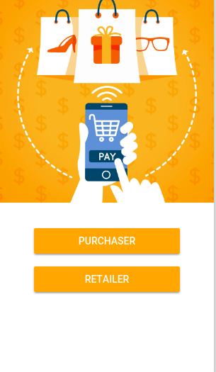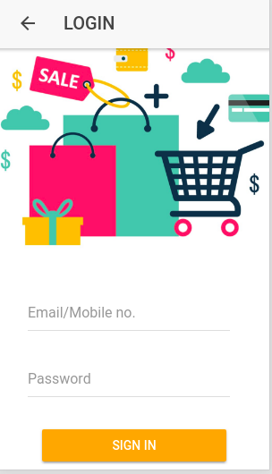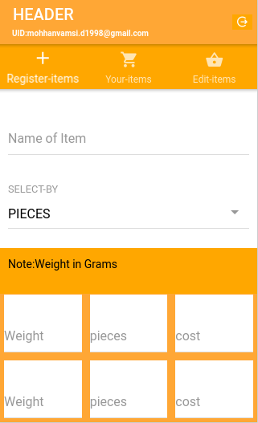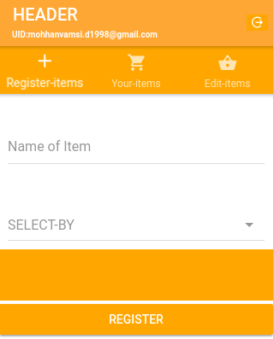

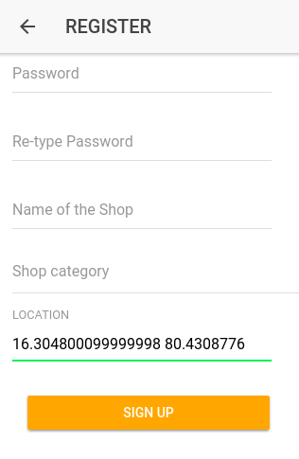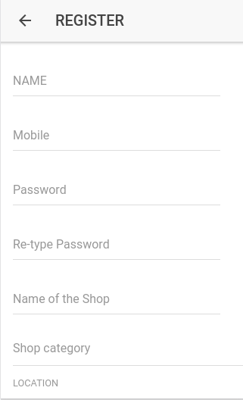

**FUTURE ENHANCEMENTS:**

* This can be improved in the case of security and app permissions.
* the customer and retailer register id can be signed by using gmail, facebook, linkedin, github, etc like social websites and open source sites.

**REFERENCES:**

1. <https://ionicframework.com/>
2. http://php.net/manual/en/pdo.query.php
3. <https://forum.ionicframework.com/t/dynamic-ion-input-value-getting/105366/2>
4. <https://forum.ionicframework.com/t/pass-ngfor-index-to-click-event/39753/8>
5. <https://www.joshmorony.com/an-introduction-to-lists-in-ionic-2/>
6. <https://forum.ionicframework.com/t/get-value-of-a-select-option-and-filter-list-of-items/88414/5>
7. <http://masteringionic.com/blog/2017-12-15-creating-a-content-filter-with-ionic-components/>
8. <https://stackoverflow.com/questions/46767431/how-to-implement-searching-and-filtering-in-ionic>
9. <https://www.w3resource.com/sql/subqueries/understanding-sql-subqueries.php>
10. <https://www.joshmorony.com/high-performance-list-filtering-in-ionic-2/>
11. <https://stackoverflow.com/questions/31851267/how-can-i-check-if-a-value-exists-in-mysql-database-table>
12. <https://stackoverflow.com/questions/19902078/pdo-bindparam-with-prepared-statement-isnt-working/19904682>
13. <https://ionicframework.com/docs/api/components/item/ItemSliding/>
14. <https://stackoverflow.com/questions/35162308/ionic-2-passing-tabs-navparams-to-tab/35176544>
15. <https://forum.ionicframework.com/t/how-to-validate-forms-with-angular-2-in-ionic-2/54687>